The Rails, The Hobo and The Java Entreprise platform
Or how to become a hobo player

First, installation

Installation of the dependancies

sudo gem install sqlite3-ruby -v=1.2.3
sudo apt-get install sqlite3
sudo gem install sqlite3-ruby
sudo gem install rails

If you are in front of some discrepancies during installation of sqlite3-ruby, you can try the following additional lines just before retrying installation.

sudo apt-get install libsqlite3-dev

Installation of the framework
Simply execute the standard gem following line:

sudo gem install hobo

First Application
Now we are going to create our first Hobo application

hobo MyLibrary

focus in the just create app directory

cd MyLibrary

And now create our first datamodel : a book modelisation

script/generate hobo_model_resource book title:string author:string year:integer resume:text note:integer

nos, we are going to create this model persistence into the default sqlite3 database

script/generate hobo_migration
(choose the 'm' option)

Ok, done. now run the rails server (WebBrick):

script/server

browser on http://localhost:3000/

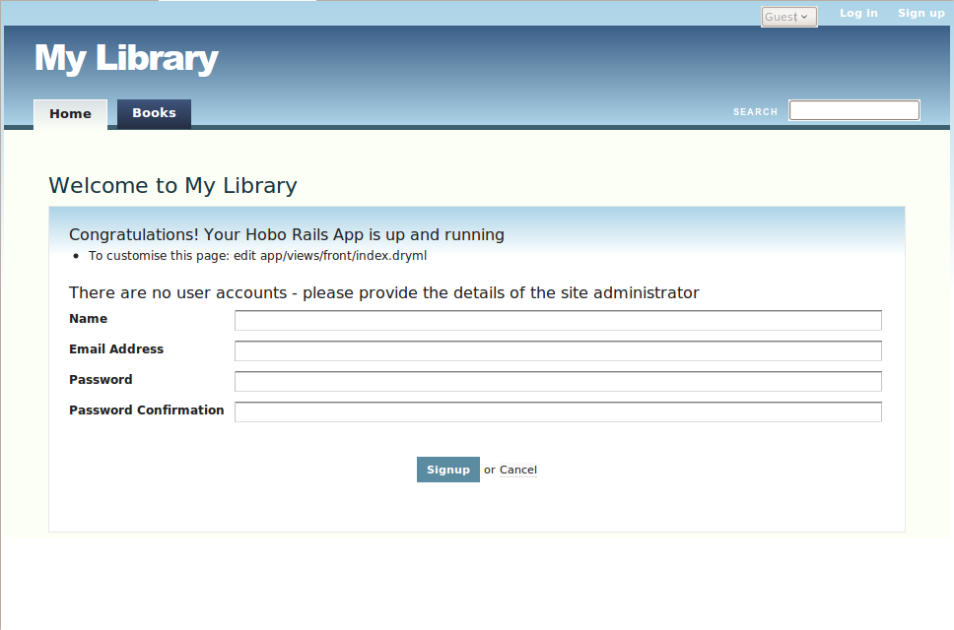
Look at the title of the application :"My Library" ! Just because we call our project "MyLibrary" (without any space), Hobo kindly titled our welcome page with a beautiful "My Library" in a good old english.

Identify yourself by creating the first user account which will act as administrator for this new application.

And now start playing with your books collection !

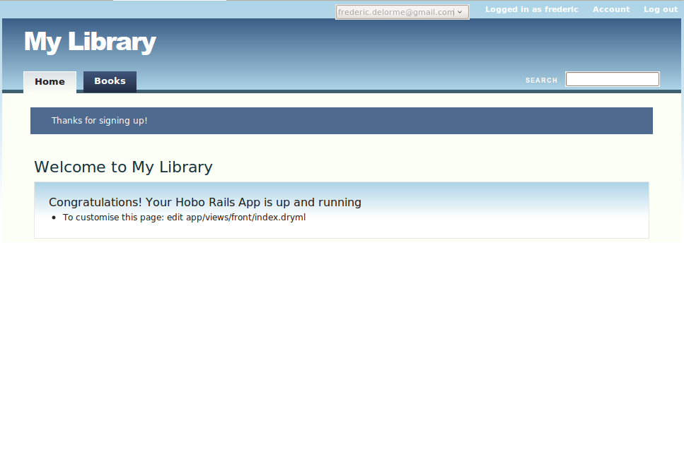

Yes I am impressed to discover how the Hobo dev team has been very careful with all details.

Second, the hobo
We have just created the first step of our library.
Now we have hundreds of books, maybe we can dispatch all these books in some categories ?

Ok, let's add categories to our web app "My Library"

script/generate hobo_model_resource category name:string sorder:integer

And we have to update the database with our new model:

script/generate hobo_migration

don't forget the 'm' option to run the migration right now !

ok, just for fun, run the application with a

script/server

browse to http://localhost:3000/ and go to the "Categories" tab..

1.View the Category tab
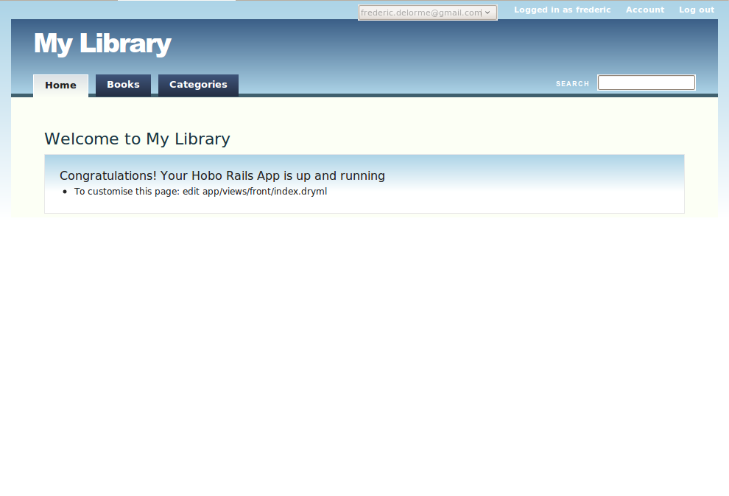

2.and add a new "Novel" category
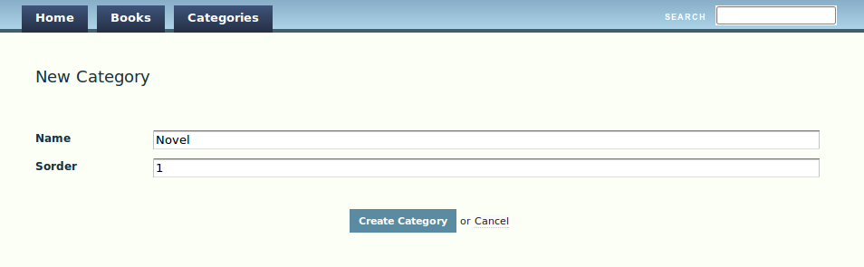

yes ok, nothing really new here. It's working just like Books.

Let's dye into the code

We are going to add the link between Book and Category, knwoing that a category can have many book, and one book belong to one category.

Open the file book.rb and just after fields declaration, add the following "belongs_to":

class Book < ActiveRecord::Base

hobo_model # Don't put anything above this

fields do
title :string
author :string
year :integer
resume :text
note :integer
timestamps
end

belongs_to :category
...
end

Open now the category.rb and add the small "has_many" property:

class Category < ActiveRecord::Base

hobo_model # Don't put anything above this

fields do
name :string
sorder :integer
timestamps
end

has_many :books
...
end

we have to generate a small migration to add this field into the Book data model.

script/generate hobo_migration

choose the 'm' option to apply modifications.

and start the server to test !

script/server

let's browse the Books page

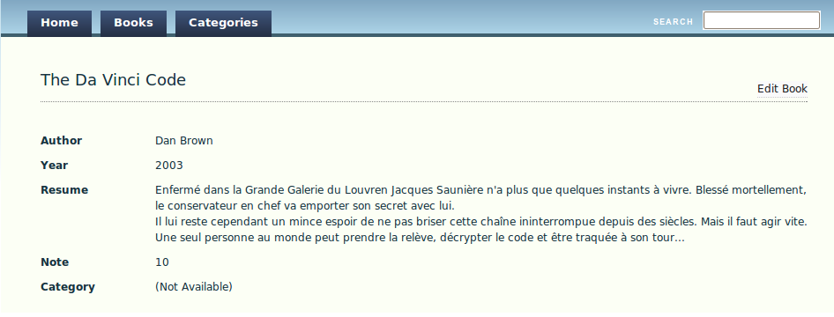

And choose one of the created book, you can see the new "Category" field at end of page.

Click the "edit book" link and you will be invited to change the value for category wich is currently set with the default "(No category)".

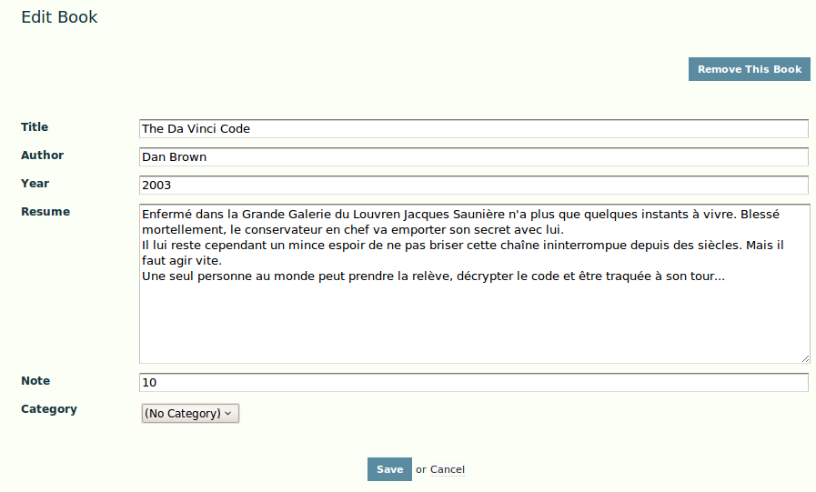

ok, back to your code editor and open the file category_hints.rb. and replace all the commented lines by the following single line.

class CategoryHints < Hobo::ViewHints

children :books

end

Telling that Category has Books has children will modify automatically the Category page, showing the number of book attached to a category.

1. What's new in the "Categories" page
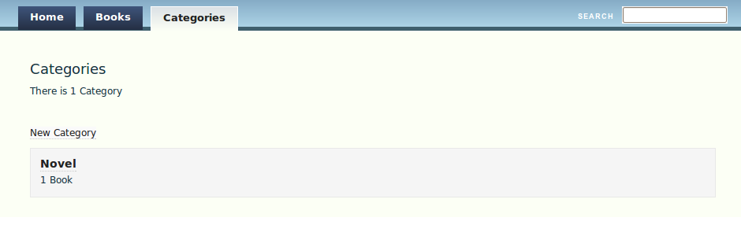

2. Let's see the detail of a Category
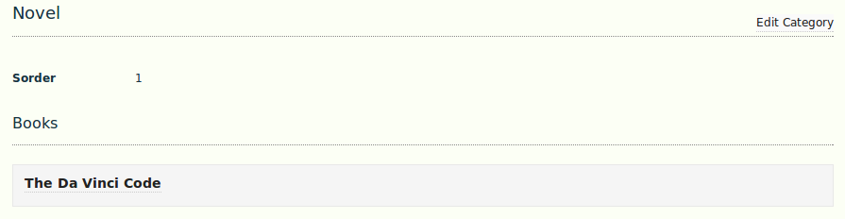

3. And on the Book side, a new top/left link appear "<<Novel"
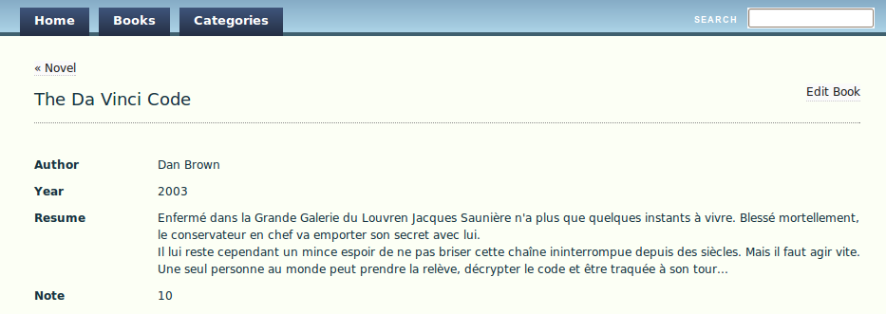

you can see that with very small add to the generated code, you considerably inflect the default behaviour of the application and the links in the model.

Even if model link declaration and manipulation already exists in Rails, Hobo brings the corresponding mechanisms for the UI side.

Forth, Jruby to master Java

Fifth, Tomcat to rule them all

